Learning Outcome

Able to Build a web application on modern cloud-based architectures and services.

# Migrating application to Cloud

## Application Migration

**What is application migration?**

Application migration is the process of moving a software application from one computing environment to another. You might, for instance, migrate an application from one data center to another, from an on-premises server to a cloud provider’s environment, or from the public cloud to a private cloud environment.

Because applications are typically built to run on particular operating systems in specific network architectures or developed for a single cloud platform, moving an application to a new environment can pose a number of challenges. It’s usually easier to migrate applications from virtualized or service-based architectures than it is to migrate those running on bare metal hardware.

Determining an overall application migration strategy involves considering each individual application’s dependencies and technical requirements, as well as your enterprise’s security, compliance, and cost constraints.

Different applications can take different paths to the cloud, even within the same technology environment. Since the early days of cloud computing, developers have referred to these application migration patterns with names that begin with “R."

## Cloud Migration Strategy

There’s a well-known framework for organizing your strategies for cloud migration: this is known as “The 6 Rs of Cloud Migration”. Not every business will perform each step but think of this as a guide to illustrate the many possible paths an organization can take. Once you review their details, you’ll have more context to understand which way to lead your migration strategy.



Image: Cloud Migration Strategy

Reference: <https://i0.wp.com/v3it.com/blog/wp-content/uploads/2021/07/cloud-migration-types.png?resize=605%2C473&ssl=1>

1. **Rehost:** Rehosting is often called “lift and shift”. Just as the name implies, there is no big architectural change to the servers and applications in this situation. They are simply taken from on-premises (the lift) and moved to the same type of system on the cloud (the shift). Organizations that are just starting their migration journey will often use the lift-and-shift strategy.

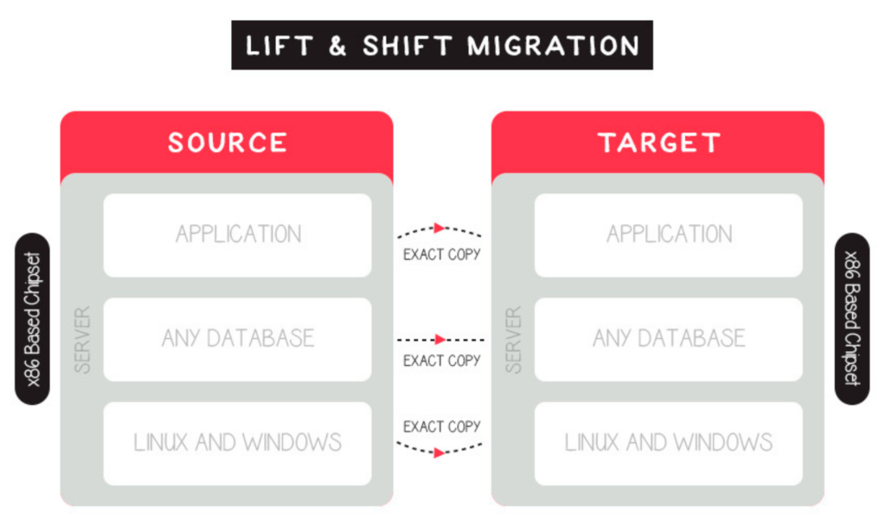

Image: Lift and shift cloud migration

Reference: <https://cloudacademy.com/wp-content/uploads/2021/12/Lift-and-shift-cloud-migration-1024x600.png>

1. **Replatform:** Replatforming is the second option. This is where we modify “lift and shift” into something more complicated but better suited to the new cloud environment. Replatforming is a process that optimizes the application during the migration phase. This requires some programming knowledge and input. You might move from your own database system to a managed DB hosted on a cloud provider. In this type of migration, you stick with similar underlying technology but modify the business model and have cloud resilience as a huge bonus.
2. **Repurchase:** Sometimes referred to as “drop and shop,” this cloud migration strategy comprises a full switch to another product. This could mean ending existing licensing or repurposing services for new platforms and services. In this instance, some examples of a “dropped” application may be a CRM system or an industry-specific app that was not created to be run on the cloud. However, it may be one that does not have modern code or one that cannot be transported from one provider to the next. When transferring to a new product or using a proprietary platform, the “repurpose” strategy is used.
3. **Refactor:** Refactoring is the fourth R, which is basically redesigning. This is often driven by a want to improve an application or service. This could be due to various factors such as difficulty in improving the environment or the need to increase the availability and reliability of an application to meet anticipated traffic spikes.The timing of refactoring is important. While it may be possible to re-architect the application during the migration stage if the application is not mission-critical, It’s generally best to do this later in the project. It’s important to remember that refactoring can take some time and requires expertise.

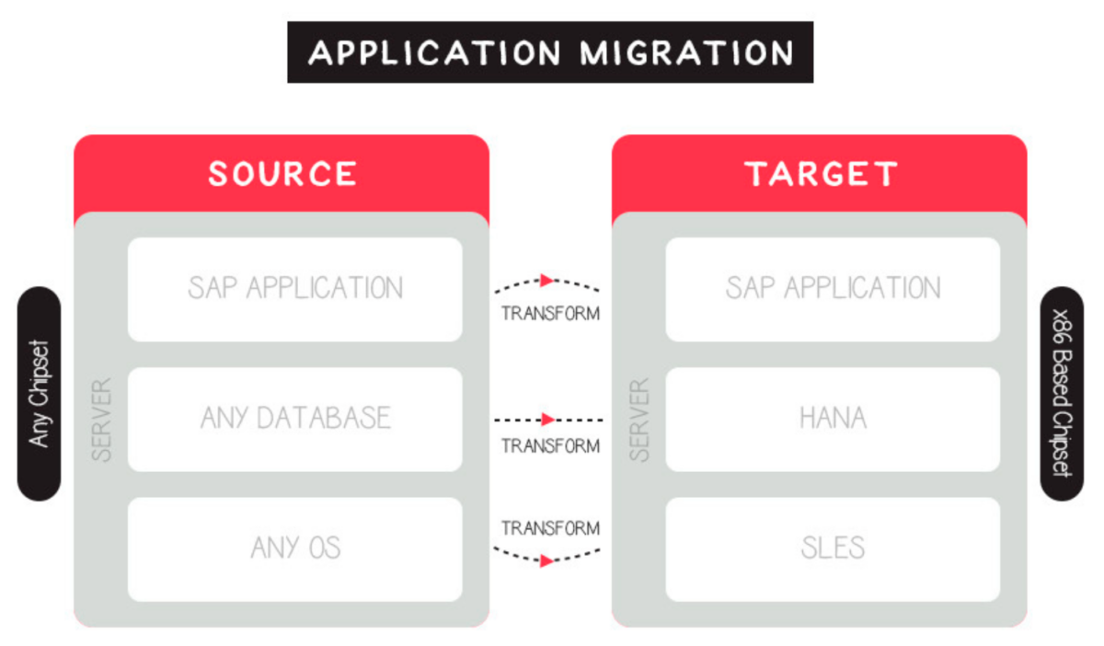

Image: Refactoring type of cloud migration

Reference: <https://cloudacademy.com/wp-content/uploads/2021/12/Refactoring-type-of-cloud-migration-1200x702.png>

1. **Retain:** Retain is the fifth strategy. Some applications may be too difficult to migrate, so you might want to keep them. This is when you jump into the hybrid space, like many other successful enterprises. There can be various reasons why you might want to keep some of your existing on-premises deployments: if you are currently subject to regulations or have rules regarding the storage or operation of certain aspects of your business applications, services, or data on-premises or in specific areas, this approach may be a good option.
2. **Retire:** We now have our final strategy: to retire services. This strategy involves identifying assets that can be retired so that the business can concentrate on services that are most used and have immediate value. This is an interesting way to approach your existing application library because even though there may be big changes to be made, you can see them as opportunities.

## Benefits of Migrating to the Cloud

Here are some of the benefits that compel organizations to migrate resources to the public cloud:

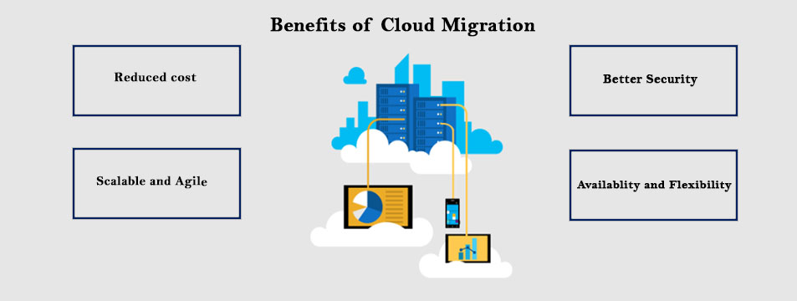

Image: Cloud Migration Benifits

Reference: <https://www.i2econsulting.com/wp-content/uploads/2020/04/Azure-2-1.jpg>

1. **Scalability -** cloud computing can scale to support larger workloads and more users, much more easily than on-premises infrastructure. In traditional IT environments, companies had to purchase and set up physical servers, software licenses, storage and network equipment to scale up business services.
2. **Cost -** cloud providers take over maintenance and upgrades, companies migrating to the cloud can spend significantly less on IT operations. They can devote more resources to innovation - developing new products or improving existing products.
3. **Performance -** migrating to the cloud can improve performance and end-user experience. Applications and websites hosted in the cloud can easily scale to serve more users or higher throughput, and can run in geographical locations near to end-users, to reduce network latency.
4. **Digital experience -** users can access cloud services and data from anywhere, whether they are employees or customers. This contributes to digital transformation, enables an improved experience for customers, and provides employees with modern, flexible tools.

## Application migration risks

Stakeholders may fear that application migrations might cause disruptions to the business or result in unanticipated costs. The most common risks include the following:

1. **Unforeseen technical challenges:** For example, an application may have so many dependencies that refactoring or Replatforming can be much more complex and time-consuming than originally thought.
2. **Unanticipated costs:** Without proper planning, businesses may incur expenses that they hadn’t budgeted for, such as new licensing fees or the training costs associated with getting employees up to speed on new tools.
3. **Unexpected downtime:** Major changes to an application can cause conflicts or issues that lead to unplanned downtime, both for the application and for connected or dependent systems.
4. **Cultural issues or change management difficulties:** Different organizations use apps differently, and those differences can create friction that slows down a migration project.

Undertaking a careful and detailed assessment of the risks and benefits associated with rehosting, re-architecting/Replatforming, or retiring each application in your portfolio can help mitigate the overall risks associated with application migration. In particular, it’s important to compare department-level costs with the total cost to the enterprise and to assess the total cost of ownership (TCO) of any hardware you’d need to maintain to keep applications on premises.

## Application migration plan in three stages

Generally speaking, the application migration planning process can be divided into three stages. In each, it’s critical to weigh the costs of all potential options, including choosing to retain some on-premises workloads.

1. **Application identification and assessment**

In this initial discovery phase, you should begin by ensuring you have a comprehensive catalog of all applications in your portfolio. You’ll then categorize the applications according to whether they have business-critical or non-critical importance, whether their value is strategic or non-strategic, and what you stand to from migrating each to the cloud. You should strive to understand each application’s value in terms these characteristics:

* Impact on the business
* Ability to fulfill crucial business needs
* Timeliness and importance of data
* Size, complexity, and manageability
* Cost of maintenance and development
* Increased value from migration to the cloud

You’ll then want to conduct a cloud affinity assessment for each application you’re thinking about migrating. During this process, you can determine which applications are ready to go as-is and which would need significant changes before they could be made cloud-ready.

You can also employ application dependency discovery tools to help you determine the feasibility of migrating a particular workload outside its current environment.

1. **Total cost of ownership (TCO) assessment**

Determining the total cost of a cloud migration project can be a complex undertaking. You’ll need to compare “what-if” scenarios for keeping applications and infrastructure on-premises with those associated with moving them to the cloud. This means you’ll have to calculate purchasing, operating, and maintenance costs for the hardware you’d maintain on-premises in either scenario and the costs of licensing software.

You’ll want to compare the monthly bill you’d get from your cloud provider in either scenario and the costs of the migration itself, including the costs of testing the new infrastructure and training employees to use updated software. Don’t forget to consider maintenance costs for legacy applications that remain on-premises.

1. **Assess overall risk and project duration**

In the final phase of migration planning, you’ll establish a timeline for the project and identify any risks or stumbling blocks that you are particularly likely to encounter.

**Legacy application migration to cloud**

Generally speaking, the older the application, the more challenging (and as a result, potentially the less worthwhile) it is to migrate to the cloud. Outdated software is problematic in many ways: it’s expensive to maintain, it can raise security concerns if it’s no longer being patched, and it tends to perform poorly in modern computing environments. Be especially thorough with your assessment of legacy applications before deciding to migrate them.

## Cloud migration checklist

To ease your transition to the cloud, prepare a checklist that helps keep the project on track by checking off each task as completed. A checklist can be as basic or exhaustive as project managers choose to make it. The following are some items to include:

* Determine which workloads will be relocated to the cloud and classify them by complexity, size, and production/not production.
* Research and select a cloud provider suitable to the workloads being relocated.
* Determine if you will need a multicloud approach based on your workloads.
* Perform a cost assessment for the migration.
* Assign a team to execute the migration.
* Communicate the goals of the migration to the team.
* Determine how much of the migration will be handled internally and by the cloud provider.
* Prioritize which workloads to migrate first.
* Prepare a plan outlining the roadmap and schedule for the migration.
* Ascertain whether the organization already uses any cloud-based applications and whether they should remain as they are or be replaced by new cloud-based services.
* Communicate to all stakeholders what to expect during and post-migration.
* Prepare a security plan for migration and post-migration.
* Establish KPIs for the migration.
* Check in with implementers along the way to review progress.
* Test, review, and make adjustments as needed.

## Application migration and IBM Cloud

IBM Cloud offers a full suite of cloud migration tools and services, ranging from IBM Assisted Migration Services, which include fully-managed migrations using the customer’s own tools, to seamless lift-and-shift migrations of VMware workloads supported through IBM’s partnership with VMware. (You can even calculate the value of migrating with IBM Cloud for VMware solutions.)

**Make you deploy-anywhere future possible**

Unlock your core applications and harness cloud-native development to become a nimble market competitor.

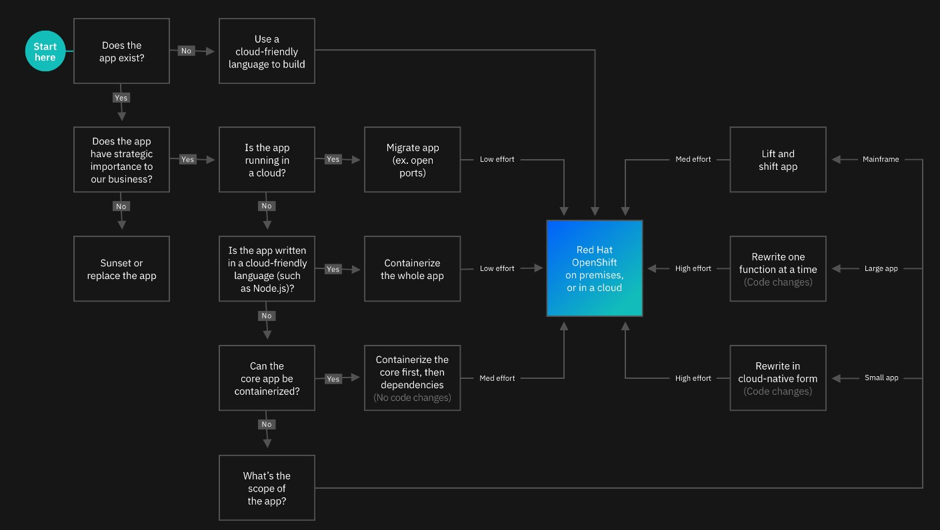

Image 1: Cloud Migration

### **Introduction**

**Tackle modernization and cloudification with IBM**

When faced with upgrading your application estate, you run into a lot of questions. Which technologies do you adopt? How can you reduce technical debt? What apps do you build new in the cloud? How can you be sure you’ll keep pace with industry changes? And how do you do it all fast? Working with IBM, you’ll have an experienced partner that can guide you.

### **IBM approach**

**Be part of the process with an end-to-end partner**

IBM works with you through your entire application transformation—from the modernization of existing infrastructure and applications to the development and deployment of applications that run on any cloud platform. Together, we’ll start small, develop an ROI-based strategy aligned to your goals and harness quick wins. Then we’ll show you how to begin to change your culture, scale across your business and make your journey to the cloud a success. Using DevOps tools, accelerators and AI-driven automation, we’ve helped clients change how they operate. We'll do the same for you.

### **Strategy**

**Develop a strategy that delivers**

Do you need to optimize and modernize? Should you rehost, replatform or redesign? Through thousands of client engagements across 20 industries, we’ve learned what works and what doesn’t. Each application estate is unique and requires a custom solution. Our assessment starts with AI- driven insights and visualizations of your applications, middleware and databases. You’ll come away with a complete ROI-driven roadmap. From there, you can implement it yourself using our software, IBM can implement it for you or IBM can manage all of it for you on an ongoing basis.

### **Modernization**

**Reduce application costs**

Yes, you can reduce your technical debt. According to a recent Forrester TEI study, IBM has helped clients optimize applications and migrate to the cloud fast, with measurable impact, including reduced compliance risk and migration cost, and improved deployment speed. Our skills, methods and tooling also go beyond modernization, helping you align your IT with business requirements, reduce your operating costs to free up innovation capital and enhance your overall application security.

### **Cloud native**

**Adopt modern dev tools and methods**

IBM provides environments, tools and methods to help you deliver applications that run anywhere

— on premises or on any cloud — faster and securely. You’ll be able to build containerized applications, optimized for scale and performance, that take advantage of continuous delivery and DevSecOps principles to reduce time to market.

### **Integration**

**Ensure access to data and application services**

Traditional integration architectures can’t collect the kinds of actionable business insights that come from real-time access to data and applications. To do this, they must modernize. IBM helps you build an architecture that’s cloud-native in design, API-led and event-driven — with fine- grain deployment through containers. This modern integration architecture empowers your teams to build the integrations they need to meet demands while lowering costs.

### **Deployment**

**Quickly deploy and manage apps at scale across clouds**

Wherever your workloads run, we can help you deploy and manage your applications securely across environments, clouds, including IBM Cloud and specialized hardware. Some problems may benefit from the portability that comes from containerization and Red Hat® OpenShift®. Other problems are better solved with a single control plane across clouds that has built-in support for security and compliance management. In other cases, it might make sense to have IBM manage your estate for you. Regardless of the approach, IBM can help you reduce costs while increasing operational efficiency and visibility.

### **Culture change**

**Evolve your culture with IBM Garage**

In IBM Garage™, we work side-by-side with you, even if it that means virtual, to uncover new ways of working that help you drive transformational change. We bring together the depth of experience and proven methodology of IBM and use enterprise design thinking to draw on your team’s wisdom and creativity. With the right people, useful data, applied technology and dedicated spaces, we can co-create with you to build cloud-native applications in as little as six to eight weeks.

**References**

1. <https://cloudacademy.com/blog/cloud-migration-benefits-risks/>
2. <https://www.ibm.com/cloud/learn/application-migration#toc-applicatio-UwMDGjMF>
3. <https://cloud.netapp.com/blog/cloud-migration-strategy-challenges-and-steps>